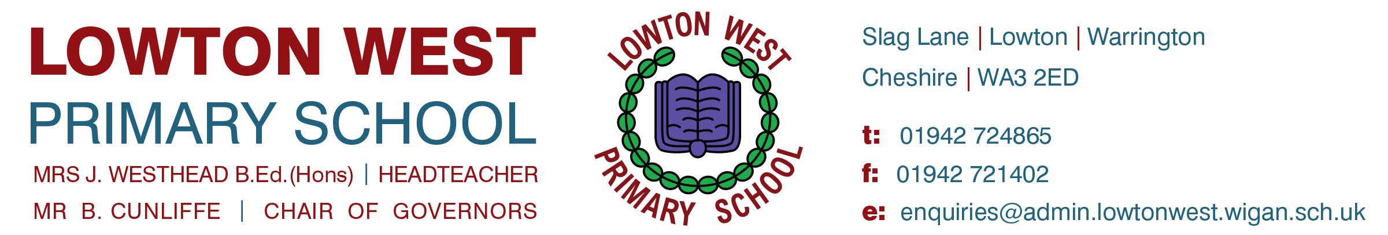

6th October 2020
LOWTON WEST ‘HOME LEARNING’ STRATEGY

Dear Parent/ Carer,

As you are aware, due to the Covid-19 crisis, individuals or groups of children may need to self-isolate from school or school may experience a local lockdown. We have therefore developed a ‘Home Learning Plan’ for each year group to enable the children who are not in school to follow the school curriculum at home.
Today, a letter will be sent out to each year group in relation to the ‘Home Learning Plan’ for that particular year group.
Your child will also be sent home with a ‘Home Learning’ exercise book and a handwriting book (or handwriting paper pack). Please keep these books in a safe place at home, ready to access in the event that your child has to isolate.
If your child has to isolate at home for any reason, he/ she will be able to access work via the Seesaw Learning Platform. The log-in details have been sent home with your child and should be kept in a safe place for quick, future reference. If you do not have these details, please contact the school office.
We expect the children to complete their ‘home learning’ work in the exercise book. We expect the same high standards of work that we see from the children in school. Work completed can then be uploaded onto Seesaw also.
Children can complete any handwriting activities in the handwriting book or on the handwriting sheets provided.
If your child does not have access to the Internet or Seesaw learning platform, a paper pack will be available and will either be sent home with your child/ available for collection (if possible). If collection is not possible, please inform school and we will arrange for the paper pack to be delivered to your home address.

If you have any queries, please contact the school office and someone will get back to you as soon as possible.
Thank you for your support in this matter.
Yours sincerely,
Mrs J.Westhead
Headteacher

