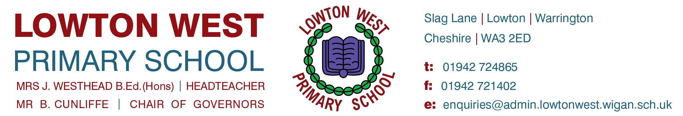

1st June 2020

Dear Parents/ Carers,
Important Update

As you are aware, we had been planning to open more widely and to increase our number of pupils as from next Tuesday 9th June. We were going to focus on continuing to provide places for the priority group by offering places to pupils for whom just one parent is a key worker.

However, following guidance received from Wigan Council today, we will now be delaying this wider opening of school until 15th June at the earliest.

Therefore, the pupils (for whom just one parent is a key worker) will not be able to be offered a place until 15th June at the very earliest.

The reduced provision care facility that is already in place will continue to run as normal, i.e. for the vulnerable pupils and pupils (for whom BOTH parents are key workers).

This is not a decision that the school has taken lightly and I would like to refer you to the letter from Professor Kate Arden (Director of Public Health – Wigan Council) that we have published on the home page of our school website (and that we will also send via School Spider). Within this letter, Professor Kate Arden outlines concerns in relation to schools increasing their pupil numbers at this current time due to not feeling assured that locally the government’s five tests can be met.

As you know, we have put the safety of our pupils, staff and families at the forefront of all decisions during this pandemic and we will continue to do so. We already have high numbers attending the reduced provision at Lowton West Primary School and, given the clear guidance from the Director of Public Health (Wigan Council), we will not be putting anyone at risk by further increasing these numbers at this current time.

As you are also aware, we are unable to offer places to children in Reception, Year 1 and Year 6. This position remains unchanged.

Thank you for your continued support. We understand that these are very challenging times for everyone and hope that you understand the difficult decisions that we are making.

We look forward to the time when we can return to the Lowton West that we know and love – the time when we will be able to welcome back all of our wonderful pupils and families.

We will keep you updated with any changes in the future and if circumstances change, we will update parents immediately.

Thank you again for all of the supportive messages that we have recently received. We read every message and they mean a great deal to us during these difficult times.

Please take care and stay safe everyone.

Yours sincerely,

Mrs J.Westhead
Headteacher

