 | LOWTON WEST PRIMARY SCHOOL  NEWSLETTER  21st January 2022
Dear Parents/ Carers,
Congratulations to this week’s Merit Award winners, Maths Masters, Star Writers and Reading Champions of the week. This week’s theme was ‘Children who keep trying even when it is difficult’.

Class | Gold | Silver | Bronze |  | Maths Masters of the week | Star Writer of the week | Reading Champion of the week
Rec | Clay H.  Samuel G | Billy W.  Eva He. | Bodhi G.  Eva Hu. |  | Daniel B.  Avie W. | George H.  Levi S. | Thomas V.  Ava K.
Year 1 | Ellis C.  Isaac C. | Rosie G-J.  Amelia C. | Ethan F.  Olivia M. |  | Victoria R.  Brodie W. | Franklin J.  Evelyn T. | Alexander M.  Oliver K.
Year 2 | Ella-Mae H-H.  Reuben C. | Zak C.  Gabriel P. | Ellen G.  Oscar O’N. |  | Warren H.  Jacob J. | Vincent B-H.  Seth P-G. | Eleanor J.  Riley P.
Year 3 | Olivia F.  Sami C. | Harry P.  Ellie H. | Skyla E.  Tyler B. |  | Theo S.  Annalise S. | Nancy P.  Marlie C. | Poppy P.  Sarah L.
Year 4 | Connie E.  Jacob H. | Jake W.  Jack S. | Cole C.  Emily E. |  | Brodie G.  Connor N. | Heidi H.  Layla G. | Taylor R-S.  Kayden B.
Year 5 | Rayan K.  Albert B. | Cameron J.  Bella W. | Imogen A.  Joseph M. |  | Olivia H.  Trisden L. | Sarocha M.  Kay F. | Zak A.  Mia E.
Year 6 | Lucy S.  Macey N. | Rhys C.  Jake C. | Finn S.  Grace C. |  | Skylar S.  Isaac W. | Niamh D.  Ruby R. | Kenzie B.  Roxie-Mae A.
Walliams |  | 1703 |  | Rowling |  | 1607
Dahl |  | 1486 |  | Cowell |  | 1639

Overall winners are Walliams with 3043 points.

School Dinners
Please note that next week (i.e. week commencing 24/01/22) will be ‘Week 3’ of the school dinner menu. A copy of the menu can be found on the school website.

End of day collection
To ensure the safety of everyone, we ask that all parents ensure that their children are supervised as they are leaving the school premises. Please note that children are not allowed to run the school path at the end of the day. Thank you.

Dogs on the premises
Please note that dogs are not allowed on the school premises. Dogs are not allowed to be carried on the school premises by their owners. Thank you.

PE Kit
Reminder: the school uniform policy was changed last year and advanced notice was given in relation to the school PE kit colours. As from January 2022, we are expecting all pupils to wear a black tracksuit (or black shorts) and a white T-shirt. The school uniform policy can be found on the school website. Please see the PE kit details below:

Reminder of P.E. Kit:
All children should have a change of clothing for P.E. as follows:
• A plain white t-shirt (no football/rugby shirts).
• Plain black shorts
• Black pumps or trainers (for outside)
• Drawstring bag with name clearly marked on the outside

During the winter a tracksuit may be worn, for P.E. outside.
Tracksuits should be plain black. No large logos.

Please Note:
The P.E. kit is part of the school uniform and should be considered as important as wearing uniform during other lessons.
Please mark all items of clothing with your child’s name and class. P.E. Kit should be left in school and will be sent home weekly.

Changes to rules for PCR testing:
As from 11th January, asymptomatic people who test positive on an LFD test will no longer have to follow up with a confirmatory PCR test. They should isolate immediately and follow the ‘Stay at Home’ guidance
However, anyone with the classic Covid symptoms of a fever, new persistent cough or lack of taste or smell should still seek a PCR test, even if they have had a recent negative lateral flow test.

Information on the changes to the self-isolation period for individuals who test positive for COVID-19
The day symptoms begin or you test positive is day zero. The next day is day one of your isolation period.
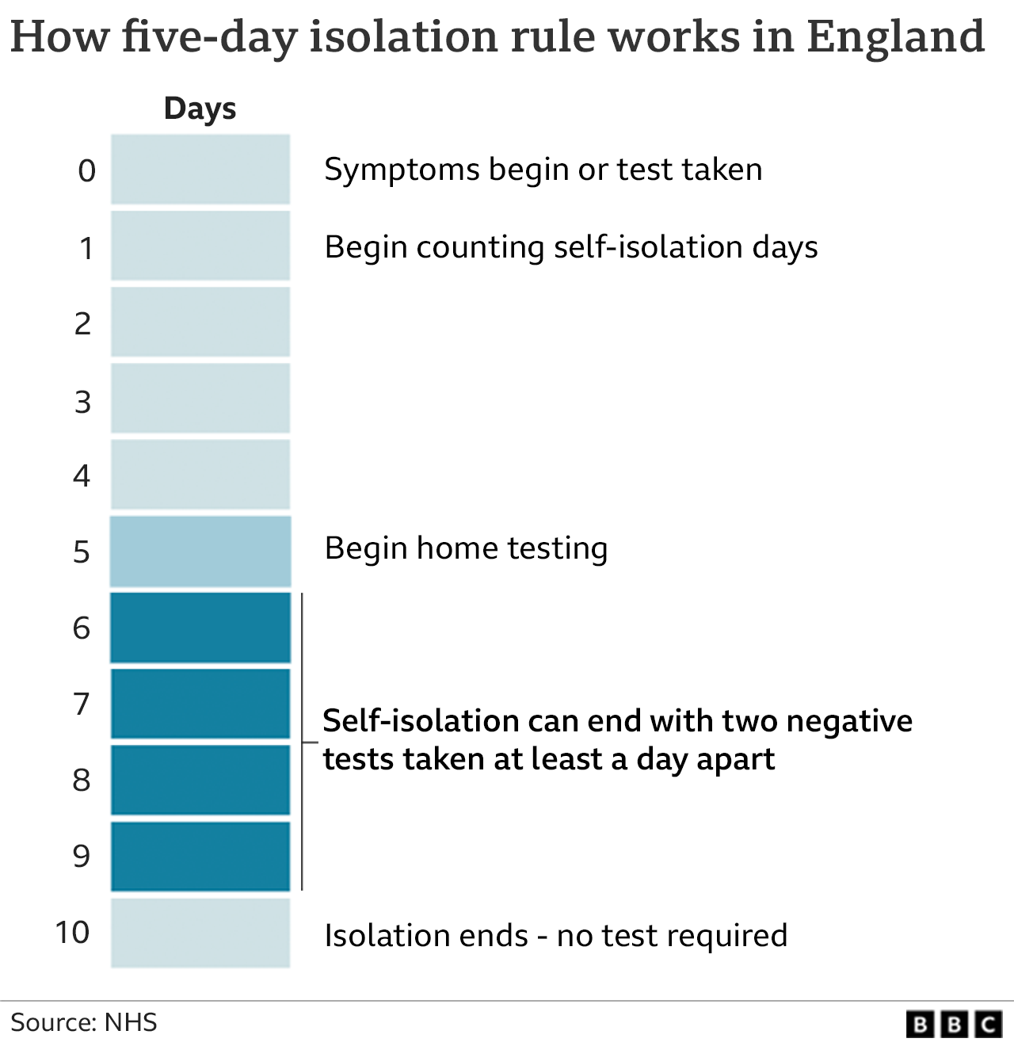
As from 17th January, people who are self-isolating with COVID-19 will have the option to reduce their isolation period after 5 full days if they test negative with a lateral flow device (LFD) test on both day 5 and day 6 and they do not have a temperature. For example, if they test negative on the morning of day 5 and the morning of day 6, they can return to their education or childcare setting immediately on day 6.
The first test must be taken no earlier than day 5 of the self-isolation period, and the second must be taken the following day. All test results should be reported to NHS Test and Trace.
If the result of either of their tests is positive, they should continue to self-isolate until they get negative results from two LFD tests on consecutive days or until they have completed 10 full days of self-isolation, whichever is earliest.
Anyone who is unable to take LFD tests or anyone who continues to have a temperature will need to complete the full 10 day period of self-isolation.

Returning from a holiday abroad
If you are returning from a holiday abroad, please remember to check the latest government guidance in relation to isolating/ testing upon your return.

Close contacts of a positive case
From 14 December 2021, adults who are fully vaccinated and all children and young people aged between 5 and 18 years and 6 months identified as a contact of someone with COVID-19 are strongly advised to take a LFD test every day for 7 days and continue to attend their setting as normal, unless they have a positive test result. Daily testing of close contacts applies to all contacts who are:
• fully vaccinated adults – people who have had 2 doses of an approved vaccine
• all children and young people aged 5 to 18 years and 6 months, regardless of their vaccination status
• people who are not able to get vaccinated for medical reasons
• people taking part, or have taken part, in an approved clinical trial for a COVID-19 vaccine

Children under 5 years are exempt from self-isolation and do not need to take part in daily testing of close contacts.

Pupils with SEND identified as close contacts should be supported by their school and their families to agree the most appropriate route for testing including, where appropriate, additional support to assist swabbing.

Further information is available in NHS Test and Trace: what to do if you are contacted and in the stay at home: guidance for households with possible or confirmed coronavirus (COVID-19) infection.

After-School Clubs

Young Voices
Young Voices choir rehearsal 24th January (collection time 4.00pm)

Multi-skills Sports Club

Year 3 - Class 7 26th January (collection time 4.15pm)

Year 3 - Class 8 28th January (collection time 4.15pm)

Best wishes,
Mrs J. Westhead
Headteacher

