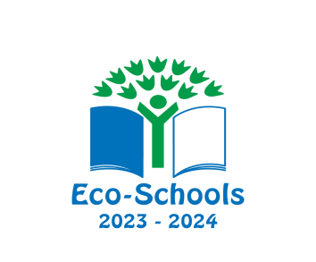
Eco Schools News
We are delighted to announce that Lowton West has been awarded a coveted Eco Schools’ Green Flag Award.
“Thank you so much for submitting such a terrific application. We have loved reading about your journey and are incredibly impressed by all you have achieved. We have no hesitation in awarding you an Eco-Schools Green Flag!”
Eco-Schools Team, July 2023
This is a huge achievement and staff at Lowton West are extremely proud of all members of the 2022-23 Eco team and the whole school community for their efforts in protecting our planet.
During the academic year 2022-23, members of the Lowton West Eco Team carried out work based on three main topics. These included Bio-diversity, Energy and Global Citizenship. Pupils worked with a range of organisations and took part in environmental campaigns such as RSPB, Switch Off Fortnight and have also started a new school orchard.
Thank you to all members of the 2022-23 Eco Team for their efforts in looking after our planet.
Eco-Committee 2023-24
Thank you to all the pupils who put themselves forward to become a member of the Eco Team. Mrs Dulhanty was astounded by the efforts pupils have made when delivering speeches to their classes. All of these pupils have supported their speeches through pictures, power points and, most of all, avid enthusiasm!
We are delighted to announce the Eco Team for the academic year 2023-24 as:
Eco Team
Class 5 | Toby H
Class 6 | Ellis MD
Class 7 | Harrison P
Class 8 | Tommy N
Class 9 | Savanna T
Class 10 | Zara H
Class 11 | Ruby F
Class 12 | Poppy P
Class 13 | Tom M
Class 14 | Max S

