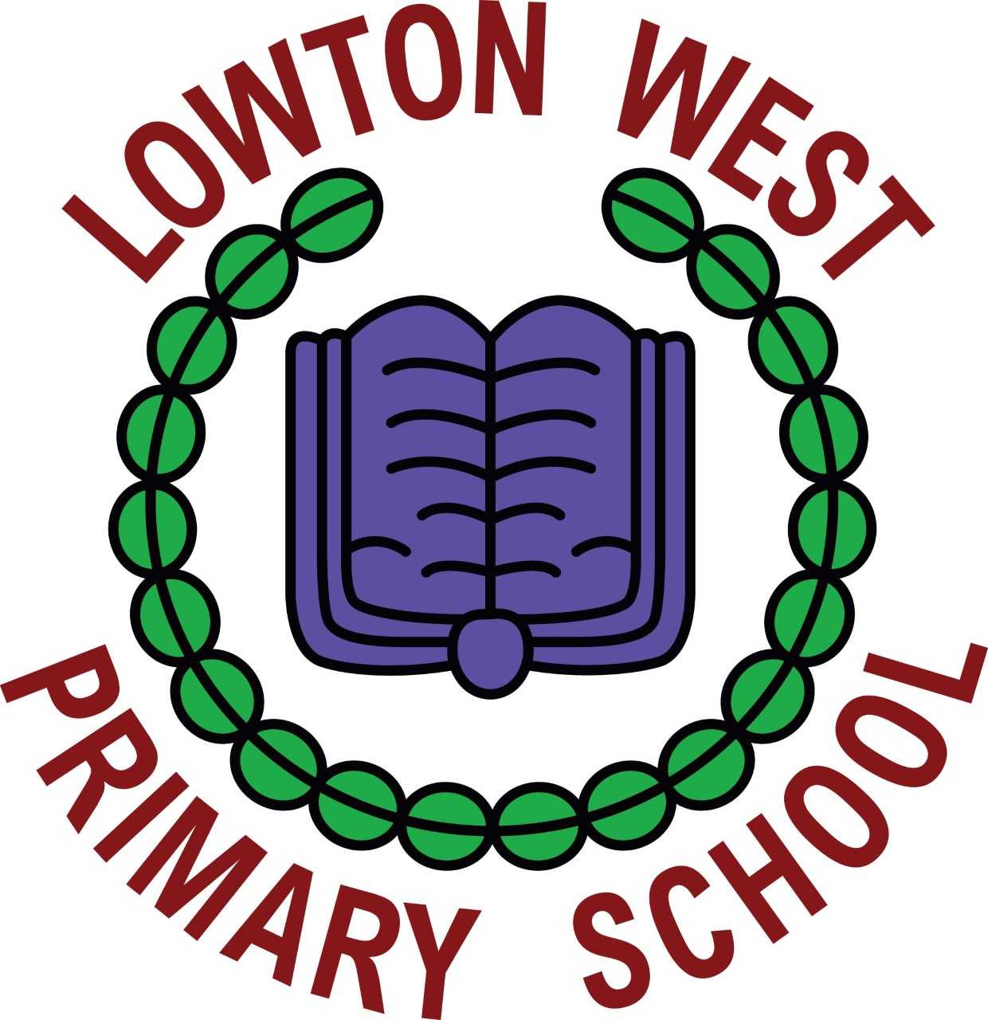
School Council Executive Committee 2022 -2023
Chairperson – Kay F
Vice Chairperson – Dastan D
Secretary – Elliot L
Treasurer – Ava F
School Council successes for the Year 2022 -2023
The School Council have been a fantastic school council and have been committed to achieving and organising many wonderful events within our school. Here are their successes they have achieved throughout this year.
Mode Shift stars Bronze Award – School travel plan

The School Council have achieved the Modeshift stars Bronze award and we now have a school travel plan. We will be continuing this next year.

We have completed travel surveys for every class in school and we will be using that information to have a walk to school week in the summer term to encourage the children to walk to school and look after the environment.
The School Council delivered Walk to School assemblies across school and encouraged children to walk to school by organising and delivering the walk to school passports in every class across school. This was a very successful event with a high number of children walking to school.

Democracy Week
Democracy is one of our British Values at Lowton West. This year, the children have taken part in class assemblies and activities as part of Democracy Week to help them gain a better understanding of what Democracy is and how having a voice is important. The School Council and Eco Committee help to give that voice within school and last week we invited the children from Years 2 to 6 to put themselves forward as a class representative for this school year. Children who would like to stand for election have presented speeches to their classes this week and we held an Election day in the hall to allow the voting process to happen. Thank you to all the children who took part this week, your presentations have been amazing!

Themed School Dinners
The School Council was given the task of choosing themed school dinners that they felt the children across school would enjoy and they linked them to upcoming events in school. The worked with Metro fresh to choose lunch options such as,St George’s Day, Easter themed lunches and Pizza themed lunches.

Red Nose Day
The School Council supported Red Nose Day by organising activities across school. The children were asked to wear something red and donate £1. The School Council delivered assemblies to both Key stage 1 and 2 to explain the importance of the fundraising the Comic Relief do. The children were very confident and clear when delivering their ideas. Well done School Council! They organised competitions in both KS1 & KS2 and judged and awarded prizes to 1st and 2nd prizes in Reception, Y1 & Y2, Y3 & Y4 and Y5 & Y6. The final total raised was £594.00.

Meeting the School Governors

On Monday 25th March, the governors held a Governors’ Conference day at the school.
The members of the school council were asked to attend the day by the governors to share with them what the school council’s role is within our school and how we are elected to the council. We shared with them our successes for this school year and what our next steps were. The governors were very interested in hearing our views and talking to us about our school. We were proud to share our achievements.

Children in Need
The School Council supported Children in Need by organising activities across school. The children were asked to wear something Spotty or yellow and donate £1. The School Council delivered assemblies to both Key stage 1 and 2 to explain the importance of the fundraising the Children in Need do. The children were very confident and clear when delivering their ideas. Well done School Council! They organised competitions in both KS1 & KS2 and judged and awarded prizes to 1st and 2nd prizes in Reception, Y1 & Y2, Y3 & Y4 and Y5 & Y6. The final total raised was £503.00

Meeting the School Governors

On Friday 3rd March 2023, the School Council received a visit from our link governor, Mrs Blewitt. The members of the school council were asked to share what the school council’s role is within our school and how we are elected to the council. We shared with them our successes so far for the school year and what we were working on at that moment. The Mrs Blewitt was very interested in hearing our views and talking to us about our school. We were proud to share our achievements.

After School clubs & Fun time Friday activity ideas

The School Council spoke with the children as part of their role in delivering pupil voice. They asked the children in their classes about what they would like school to offer in terms of after school clubs and ideas for Fun time Friday activities. The children brought back a fantastic range of ideas and collated 2 lists for staff in school. The after school list was shared with Mrs Westhead and Mrs Willoughby so they could look at provision and to inform booking choices. Miss Green collected the ideas for Fun time Friday and shared them with staff at the weekly Staff Meeting. Staff then chose an activity from the list to ensure the children’s reward afternoon was something they would enjoy.

Next Steps – 2023 -2024
In the next few weeks, we will electing a new School Council and we will announce who will be continuing the excellent work that last year’s council implemented throughout school.We will keep you updated.
Watch this space for more news later this term…

